

| **Course Code: CSE111** |
| --- |
| **Course Title: Programming Language II** |
| **Classwork No: 02** |
| **Topic: Functions** |
| **Number of tasks: 6** |

**Task: 1**

You are one of the gym instructors at AmiKenoMota. You decide to provide a customized diet and exercise plan based on the BMI of an individual. You measure the weight in kilograms and the height in meters and calculate the BMI before a plan can be decided. Write a BMI function that takes in two values, weight in kg and height in cm, and print the score along with the condition. (Make sure to convert cm into m before calculation)

BMI(height, weight)

������ = ����/��2

Based on the BMI score, **return the following output**.

● < 18.5- Underweight

● 18.5 - 24.9 - Normal

● 25 -30 - Overweight

● > 30 – Obese

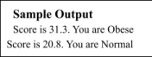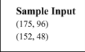

**Task: 2**

You want to order a burger from Chillox through the FoodPanda app. You have to calculate the total price. Write a function that will take the name of the burger and place(Mohakhali/Outside of Mohakhali) as input. Use the default argument technique for taking place input.

| **Menu** | **Price(Tk)** |
| --- | --- |
| BBQ Chicken Cheese Burger 250 |  |
| Beef Burger | 170 |
| Naga Drums | 200 |

Hint: Total Price = meal_cost + delivery_charge + tax Note that:

● If your home is in the Mohakhali area then your delivery charge is 40 taka else 60 taka

● Your tax rate is 8% of your meal.

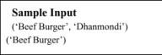

**Task 3**

A company named Sheba.xyz has recently moved from its old domain to a new one. However, a lot of the company's email addresses are still using the old one. Write a function in Python that replaces this old domain with the new one for any outdated email addresses. Keep it the same if the email address contains the new domain. (Do not use builtin replace function)

Firstly, define a “replace_domain” function that accepts three parameters *The email address to be checked

*The new domain

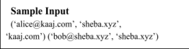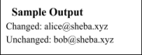* The old domain (Use Default argument technique to handle this)

**Task 4**

Write a program that checks whether a given string is a palindrome or not. Note: A palindrome is a word, phrase, or sequence that reads the same way backward as forward. For palindromes, any spaces in the middle are not considered and should be trimmed.

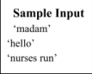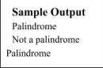

**Task 5**

Write a function that takes the number of days as input and prints the total number of years, number of months, and number of days as output.

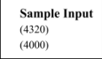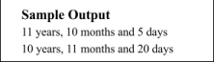

**Task 6**

You are a class teacher at a kindergarten school. As a task, you asked your students to write a paragraph. Unfortunately, you will notice that most of the students did not use capital letters correctly. Your task is to write a function that takes a string as its only parameter and returns a new copy of the string that has been correctly capitalized. Your function should:

● Capitalize the first letter in the string

● Capitalize the first letter after a full-stop, exclamation mark, or question mark ● Capitalize the word “i” if it is in lowercase.

Summary: You have to write a function that reads a string from the user and capitalizes it. The string is then returned and displayed.

